ACTIVITY

Lab Worksheet

Hypotheses
Activity 1
Bioremediation of Oil
Tubes 1 and 2:

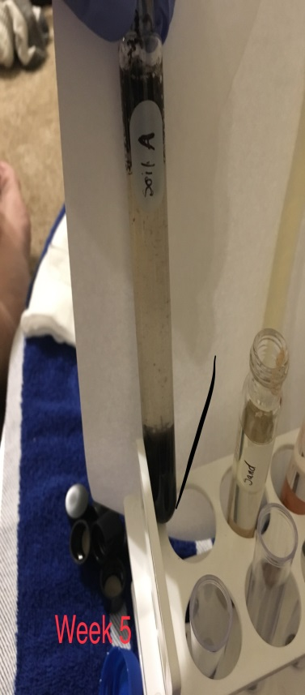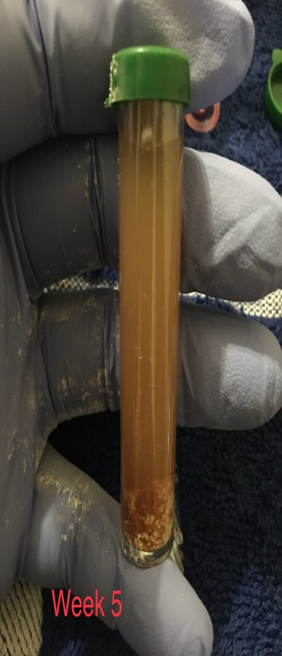

Tubes 3 and 4:

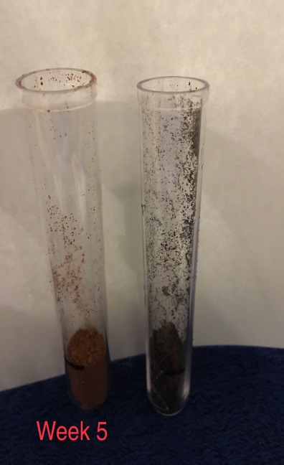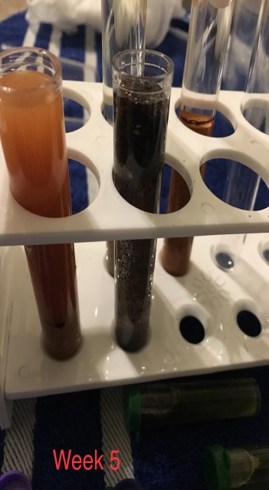

Tubes 5 and 6:
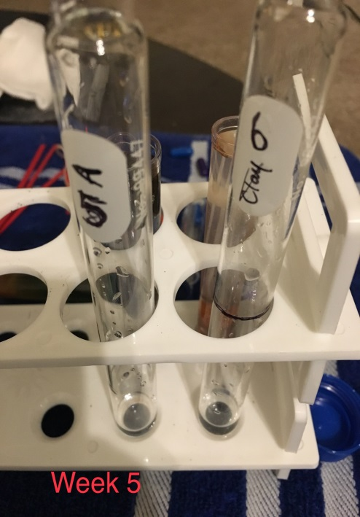

Observations/Data Tables

Data Table 1. Tubes 1 and 2 Observations

Day | Tube 1 | Tube 2
0  (Initial setup) | Tetrazolium remains typically colourless | Tetrazolium remains typically colourless
1 | Tetrazolium remains typically colourless | Tetrazolium which was colourless turns pink
2 | Tetrazolium remains typically colourless | Tetrazolium which was colourless turns pink
3 | Tetrazolium remains typically colourless | Tetrazolium which was colourless turns pink

Continued on next page

Data Table 2. Tubes 3 and 4 Observations

Day | Tube 3 | Tube 4
0  (Initial setup) | The colour of water remains colourless with the oil drops ring. | The colour of water remains colourless with the oil drops ring.
1 | The colour of water remains colourless with the oil drops ring. | The colour of water remains colourless but the oil drops ring disintegrates
2 | The colour of water remains colourless with the oil drops ring. | The colour of water remains colourless but the oil drops ring disintegrates
3 | The colour of water remains colourless with the oil drops ring. | The colour of water remains colourless but the oil drops ring disintegrates

Data Table 3. Tubes 5 and 6 Observations
Chosen environmental factor to alter/change:

Day | Tube 5 | Tube 6
0  (Initial setup) | The colour of water and tetrazolium remains colourless with the oil drops ring visible | The colour of water and tetrazolium remains colourless with the oil drops ring visible
1 | The tetrazolium disintegrates in the presence of the microbial solution to pink and the drops of oil disintegrate too. | The tetrazolium disintegrates in the presence of the microbial solution to pink and the drops of oil disintegrate too.
2 | The tetrazolium disintegrates in the presence of microbial solution to pink and the drops of oil disintegrate too. | The tetrazolium disintegrates in the presence of microbial solution to pink and the drops of oil disintegrate too.
3 | The tetrazolium disintegrates in the presence of microbial solution to pink and the drops of oil disintegrate too. | The tetrazolium disintegrates in the presence of microbial solution to pink and the drops of oil disintegrate too.

Continued on next page

ACTIVITY

Lab Worksheet continued

Photographs
Day 0 (initial setup)

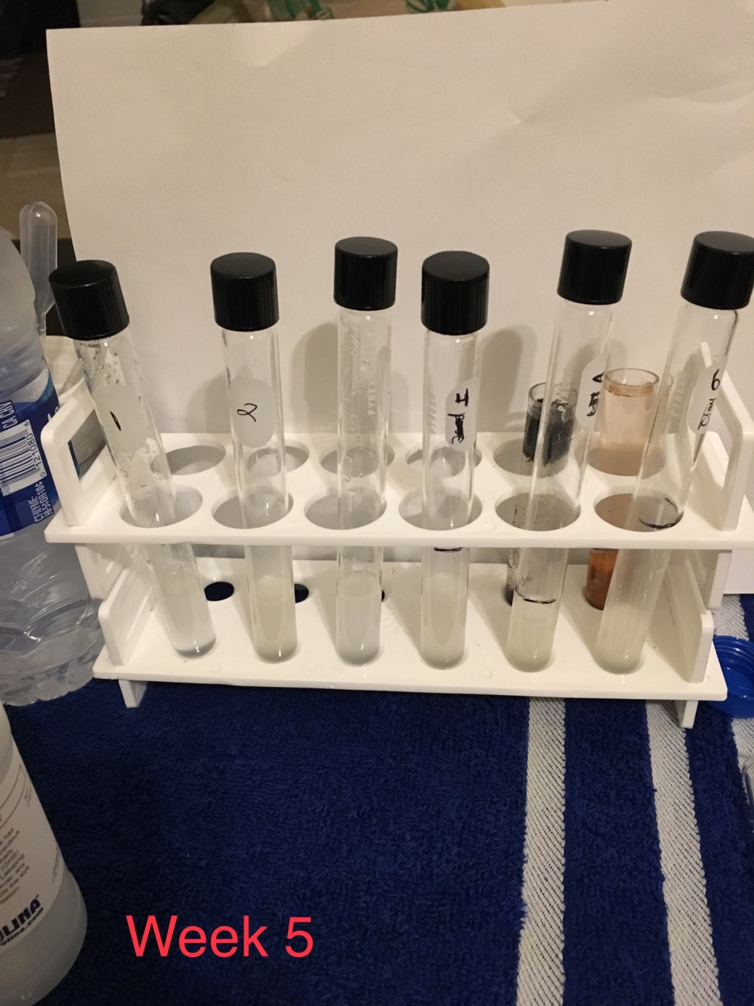

Day 1.

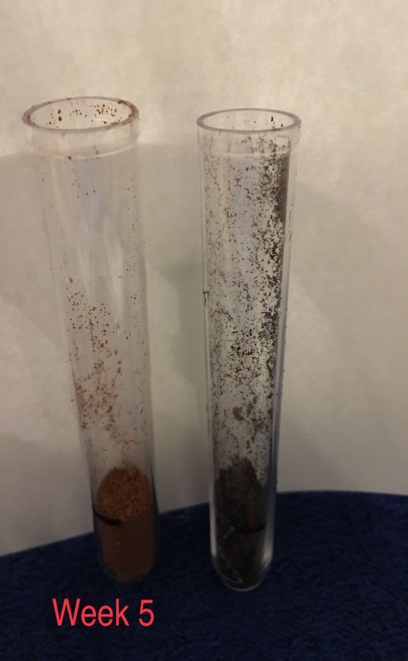

Day 2.

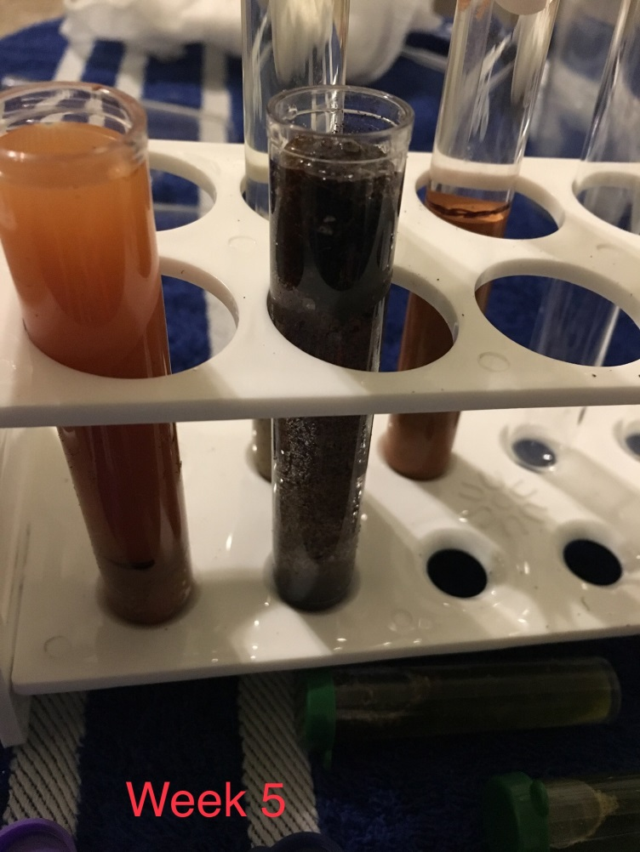
Day 3.

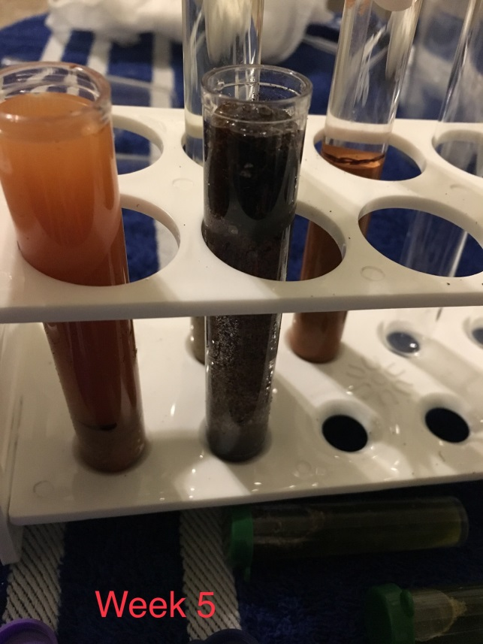

Lab Questions
Please answer the following entirely in your own words and incomplete sentences: Introduction
- Background—What is important to know about the topic of this lab? Use at least one outside source (other than course materials) to answer this question. Cite the source using APA format. Answers should be 5–7 sentences in length.
This topic is about oil nature, how it causes pollution and how microbes can be used to break down oil to reduce pollution. Bioremediation refers to the use of living organisms to clean down the environmental pollution, that is, the use of microorganisms which consume oil.

- Outcomes—What was the main purpose of this lab?
Describing the chemical nature of oil and explore the general process which microbes use to break down oil.

- Hypotheses—What were your three hypotheses for this lab? Identify each hypothesis clearly, and explain your reasoning.
- Manipulation of the nutritional composition of the spill site to enhance the activity of indigenous oil-eating microbes. Since the oil has deprived the circulation of air in the water, it is necessary to first introduce nutritional composition which will assist the natural microbes to survive under the limited oxygen supply.
- Augmenting naturally occurring microbes with special mixtures of non-native, oil-degrading microorganisms. The use of naturally occurring microbes is preferred because they have no negative effects on nature.
- Utilizing genetically engineered microorganisms specifically designed to degrade oil effectively. If the microbes have to be human-made, they are recommended to be genetically engineered such that they will match with the genetic background of wherever they are to be applied. Thus they will not have any negative effects on the other microorganisms in the water.

Materials and Methods
- Using your own words, briefly describe what materials and methods you used in each of the activities. Your answer should be sufficiently detailed so that someone reading it would be able to replicate what you did. Explain any measurements you made.
Materials used:
- Rid-X® Septic System Treatment (powder), 20 g
- 10 plastic pipes, 3 mL, graduated
- 6 Culture tubes with caps
- Graduated cylinder
- Cheesecloth
- 2 Plastic cups
- A bag containing tetrazolium indicator powder (0.02 g) and distilled water (100 mL), 0.02%
Methods used:
- Experiment to test the effects of one of these factors on the breakdown of oil using materials from your environment. Two tubes are provided in your kit to perform your test
- To test the effects of your chosen environmental factor on the breakdown of oil by microorganisms.
- To examine the change in appearance and physical properties of the oil in the presence of microorganisms.

Discussion
- Based on the results of each activity, explain whether you accepted or rejected your hypotheses and why.
According to the results of the lab, I agree with the hypothesis. It is true that microbes can be used as a natural oil-degrading agent.

- What important information have you learned from this lab? Use at least one outside source (scholarly for full credit) to answer this question. Cite the source using APA format.
Answers should be 5–7 sentences in length.
The main thing I learned from this lab is the necessity to preserve our fish populations and the sea in general. However, scientists have made a good step in the introduction of microbes to degrade the oil spills in the seas and lakes. However, humans should be responsible not to spill oil into water sources since oil is a great danger to fish life. I learned that the speed at which microbes break down substrate can be affected by water salinity, the temperatures, exposure to sunlight and availability of limited nutrients.

- What challenges did you encounter when doing this lab? Name at least one.
The major challenge faced during this lab is the unavailability of sufficient natural microbes to conduct the activity.

- Based upon your results in this lab, what next step(s) might a scientist take to determine how microbes might be used to clean up oil spills to better safeguard fish populations?
Scientists can advance the science of microbes further by doing genetic research which will ensure that the microbes can survive for a longer time in the water and even reproduce themselves. This will make sure that any oil spills occurring will be degraded immediately hence saving the fish populations in an advanced way.

Literature Cited
- List the references you used to answer these questions. (Use APA format, and alphabetize by the last
Name.)
Atlas, R. M., & Bartha, R. (1992). Hydrocarbon biodegradation and oil spill bioremediation. In Advances in microbial ecology(pp. 287-338). Springer, Boston, MA.
Swannell, R. P., Lee, K., & McDonagh, M. (1996). Field evaluations of marine oil spill bioremediation. Microbiol. Mol. Biol. Rev., 60(2), 342-365.

Now copy and paste your answers into the Lab Report provided. Include the data tables and photographs. You may wish to make minor edits to enhance the flow of your resulting lab report.

